# Lecture # 7:

**Objective:**

* Combo-box
* Picture Box
* Dialog Result
* Color Dialog
* Open File Dialog

# COMBOBOX:

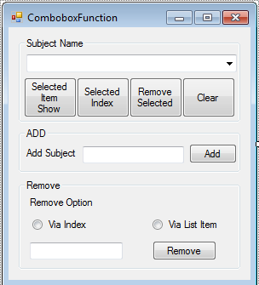

using System;

using System.Collections.Generic; using System.ComponentModel; using System.Data;

using System.Drawing; using System.Linq; using System.Text;

using System.Windows.Forms;

namespace COMBOBOX

{

public partial class Form1 : Form

{

public Form1()

{

InitializeComponent();

}

private void groupBox1_Enter(object sender, EventArgs e)

{

}

private void btnRemove_Click(object sender, EventArgs e)

{

if (txtRemove.Text != string.Empty)

{

if (rdobtnIndex.Checked)

{

try

{

}

int ehIndex = int.Parse(txtRemove.Text); cmbxSubject.Items.RemoveAt(ehIndex);

catch (Exception)

{

MessageBox.Show("Index should be numeric"); return;

}

}

else

{

cmbxSubject.Items.Remove(txtRemove.Text);

}

}

}

private void txtExit_Click(object sender, EventArgs e)

{

Application.Exit();

}

private void btnShowSelected_Click(object sender, EventArgs e)

{

if (cmbxSubject.SelectedIndex == -1)

{

MessageBox.Show("No Element is selected"); cmbxSubject.Focus();

}

else

{

MessageBox.Show(cmbxSubject.SelectedItem.ToString());

}

}

private void btnShowIndex_Click(object sender, EventArgs e)

{

if (cmbxSubject.SelectedIndex == -1)

{

MessageBox.Show("No Element is selected"); cmbxSubject.Focus();

}

else

{

MessageBox.Show(cmbxSubject.SelectedIndex.ToString());

}

}

private void btnRemoveItem_Click(object sender, EventArgs e)

{

if (cmbxSubject.SelectedIndex == -1)

{

MessageBox.Show("No Element is selected"); cmbxSubject.Focus();

}

else

{

cmbxSubject.Items.Remove(cmbxSubject.SelectedItem.ToString());

}

}

private void btnClear_Click(object sender, EventArgs e)

{

cmbxSubject.Items.Clear();

}

private void btnAdd_Click(object sender, EventArgs e)

{

if (txtAdd.Text == string.Empty)

{

MessageBox.Show("No element to be added"); txtAdd.Focus();

}

else

{

cmbxSubject.Items.Add(txtAdd.Text);

}

}

}

}

# PICTURE BOX:

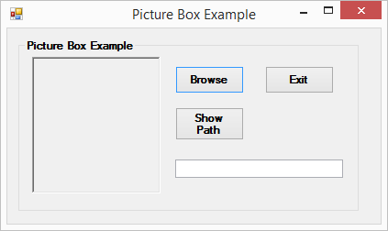

using System;

using System.Collections.Generic; using System.ComponentModel; using System.Data;

using System.Drawing; using System.Linq; using System.Text;

using System.Windows.Forms;

namespace COMBOBOX

{

public partial class pICTUREBOX : Form

{

public pICTUREBOX()

{

InitializeComponent();

}

private void button1_Click(object sender, EventArgs e)

{

DialogResult dr = openFileDialog1.ShowDialog(); if (dr == DialogResult.OK)

{

pbx.Image = Image.FromFile(openFileDialog1.FileName);

}

}

private void btnExit_Click(object sender, EventArgs e)

{

Application.Exit();

}

private void btnPath_Click(object sender, EventArgs e)

{

if (pbx.Image != null)

{

txtPath.Text = openFileDialog1.FileName;

}

}

}

}

# COLOR DIALOG BOX:

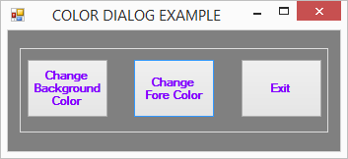

using System;

using System.Collections.Generic; using System.ComponentModel; using System.Data;

using System.Drawing; using System.Linq; using System.Text;

using System.Windows.Forms;

namespace COMBOBOX

{

public partial class COLORDIALOG : Form

{

public COLORDIALOG()

{

InitializeComponent();

}

private void button1_Click(object sender, EventArgs e)

{

DialogResult dr = colorDialog1.ShowDialog(); if (dr == DialogResult.OK)

{

this.BackColor = colorDialog1.Color;

}

}

private void button2_Click(object sender, EventArgs e)

{

DialogResult dr = colorDialog1.ShowDialog(); if (dr == DialogResult.OK)

{

this.ForeColor = colorDialog1.Color;

}

}

private void button3_Click(object sender, EventArgs e)

{

Application.Exit();

}

}

}